**User manual of Hearing Date:**

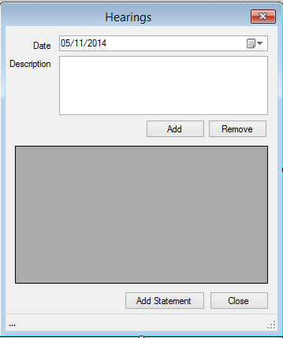

* **This is a hearing date form, where the hearing dates of the cases are stored.**
* **In this form user can also add, remove description and add statement.**